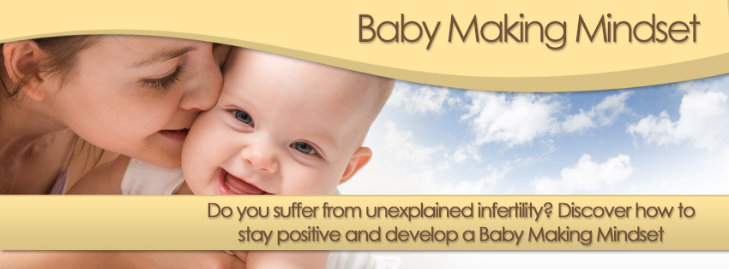
YOUR BABY MAKING MINDSET PROFILE

The Baby Making Mindset is all about having a positive relaxed attitude to getting pregnant – not always an easy thing to do. Discover how close you are to having a Baby Making Mindset by completing the questions below.

Score each of the following questions according to how you usually feel (not just around day 28 of your cycle). Score 1 for “No” and 5 for “Yes” and 2, 3 and 4 covers the range between 1 and 5:-

Q1 I think I will never get pregnant
1__________2__________3__________4__________5

Q2 I feel bad if a friend or family member tells me they are pregnant
1__________2__________3__________4__________5

Q3 My sex life is much worse than it used to be (quality as well as quantity)
1__________2__________3__________4__________5

Q4 I’m more inclined to feel sad now
1__________2__________3__________4__________5

Q5 I now avoid some friends because they’ve got children or are insensitive to how I feel about getting pregnant
1__________2__________3__________4__________5

Q6 I always know exactly which day I am at in my menstrual cycle
1__________2__________3__________4__________5

Q7 Even my family don’t know that I want to conceive
1__________2__________3__________4__________5

Q8 I feel anxious all the time
1__________2__________3__________4__________5

Q9 I know so much about fertility issues I could write a book on the subject
1__________2__________3__________4__________5

Q10 Getting pregnant has taken over how I feel most of the time
1__________2__________3__________4__________5

Q11 I often feel afraid that time’s running out
1__________2__________3__________4__________5

Q12 I don’t feel normal/complete/I feel my body’s let me down
1__________2__________3__________4__________5

Q13 I’m constantly looking for reasons why I’m not getting pregnant
1__________2__________3__________4__________5

Q14 I’m often in the grip of negative emotions such as anger, guilt, envy, frustration
1__________2__________3__________4__________5

YOUR BABY MAKING MINDSET PROFILE RESULTS:

0 – 14 You seem to be keeping your desire to get pregnant in perspective. Good work.

14 – 27 You may want to take some action to prevent your desire to get pregnant from taking over your life. Check out the section below to see where you can best benefit from some action.

28 – 41 Your desire to get pregnant may be affecting your life in a negative way. In fact, you may be in danger of sabotaging your best intentions! Give yourself a break and consider improving your coping skills.

42 – 55 Wanting a baby may be taking over your life and you may be developing thought and behaviour patterns that make it even less likely that you’ll be successful in your desire. Consider making major shifts in your thinking before it impacts on your physical and mental well-being.

56 – 70 Your desire for a baby may be causing you physical and psychological harm. Consider a visit to your doctor or a counsellor to help bring your thinking into better balance.

HOW TO IMPROVE YOUR BABY MAKING MINDSET EFFORTS:

If you want to take action to improve your Baby Making Mindset, check out your highest scores and discover what you can do to improve things.

Questions 1, 11 & 12 Work on developing a more positive belief system
Questions 2, & 14 Learn how to manage your emotions more effectively
Questions 3, 5, 7 Work on improving your relationships
Questions 4 & 8 Learn how to relax and reduce stress
Questions 6, 9 & 13 Learn how to bring a bit more balance into your life to stop you obsessing

DISCLAIMER
This Baby Making Mindset Profile is for guidance only. It is not based on psychological or scientific study and should not be taken as such. If you feel your physical, mental or emotional wellbeing is affected by your desire to have a baby, you should consult your Doctor.

